Lab 4: Dynamic html with JavaScript

# Objectives

* 1. To learn the fundamentals of the DOM hierarchy
  2. To learn about event-driven programming
  3. To become familiar with JavaScript
  4. To perform asynchronous http requests using AJAX

# Procedure

## JavaScript

* + 1. Perform the following tutorials at w3schools:
       1. Perform [the tutorial on the HTML DOM](https://www.w3schools.com/js/js_htmldom.asp) until Forms, inclusively, skipping anything CSS-related (note that “classes” are part of CSS).
       2. Perform the [JavaScript tutorial](https://www.w3schools.com/js/default.asp) from the start until “Variables”, inclusively (note that we will not use the “let” keyword and you can skip it).
       3. Perform the [tutorial on Events](https://www.w3schools.com/js/js_events.asp).
       4. Perform [the tutorial on Debugging](https://www.w3schools.com/js/js_debugging.asp).
    2. Using inline JavaScript, create a button that pops up an alert when you click it and deploy it to your website. Include a screenshot.

* + 1. Create a JavaScript event handler and deploy to your website: **☹ just change any text using innerHTML on click**
       1. Use internal JavaScript (inside <script> tags) to define your event handler function.
       2. Invoke your event handler in the onclick event of a button.
       3. In your function, change the text inside a <p> element using document.getElementById(). Use the innerHTML property.
       4. Include a screenshot.

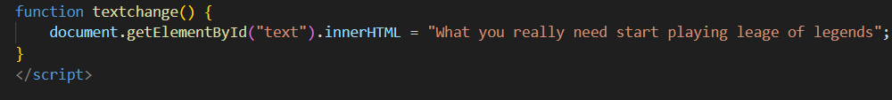

* + 1. Modify your event handler or add a new one to [toggle the visibility setting](https://www.w3schools.com/howto/howto_js_toggle_hide_show.asp) of another element. Include a screenshot.

* + 1. Implement an event handler that [changes the image source](https://www.w3schools.com/jsref/prop_img_src.asp) of an img element and screenshot.

* + 1. Implement an event handler that changes the text of a clicked button:
       1. In the onclick event of the button, invoke your event handler, passing itself as a parameter using the keyword this; e.g. onclick="myFunction(this);"
       2. Create an event handler that accepts an element as an argument, e.g. function myFunction(elem).
       3. Change the innerHTML of the passed argument to change the text of the button, e.g. elem.innerHTML="hello world";
       4. Screenshot.

* + 1. The onblur event is triggered when a field loses the focus and is frequently used to implement form validation. Implement, in your form, event handling that uses the onblur event of a required field to make visible text reading “This field is required” if the user has left the field blank.



## AJAX

* + 1. Perform the [AJAX tutorial](https://www.w3schools.com/js/js_ajax_intro.asp) until AJAX PHP.
    2. In your web site, implement a simple AJAX application that asynchronously retrieves and displays the contents of a text file on your server when a button is pressed.



* + 1. What are the advantages of using JavaScript to asynchronously make http requests and dynamically updating the page over the traditional synchronous methods we have learnt?

**We are able to much easily change the output page through another text file saved in the server. This makes it much easier to retriever large amount of prepared information instead of manually writing them down.**

Include a link to your GitHub commit for both parts in your submission.

**The first part:** <https://github.com/peasent3/webserverfunds/commit/aa89fda5a7ebb78d92a6b2b17d2717c03ec5ce36>

**This is for part 2:**

[**https://github.com/peasent3/webserverfunds/commit/18a86a092e8ecf1ddfac8945ba17f05fa8926aeb**](https://github.com/peasent3/webserverfunds/commit/18a86a092e8ecf1ddfac8945ba17f05fa8926aeb)